Samuel Raumin

Dr. Mei Klein

ECE 1310 – 03

February 3, 2020

Homework 2 Question 2.26

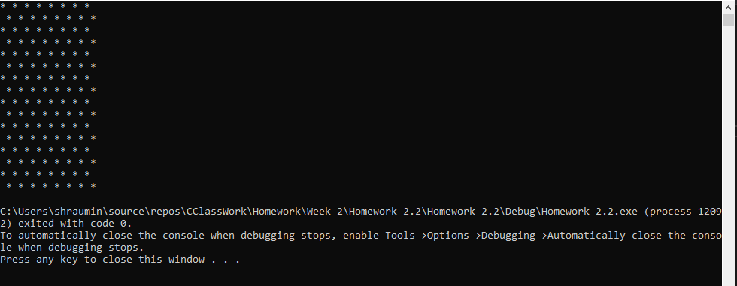

#include <iostream>

using namespace std;

int main() {

cout << "\* \* \* \* \* \* \* \* \n";

cout << " \* \* \* \* \* \* \* \* \n";

cout << "\* \* \* \* \* \* \* \* \n";

cout << " \* \* \* \* \* \* \* \* \n";

cout << "\* \* \* \* \* \* \* \* \n";

cout << " \* \* \* \* \* \* \* \* \n";

cout << "\* \* \* \* \* \* \* \* \n";

cout << " \* \* \* \* \* \* \* \* \n";

//first print off using cout line by line output

for (int i = 0; i < 8; ++i) {

for (int j = i; j < i+16; ++j) {

if (j % 2 == 0) {

printf("\*");

}

else {

printf(" ");

}

}

printf("\n");

}

}

Math based printout with nested for loop